**Custom Keyboard Design (Progress Report)**

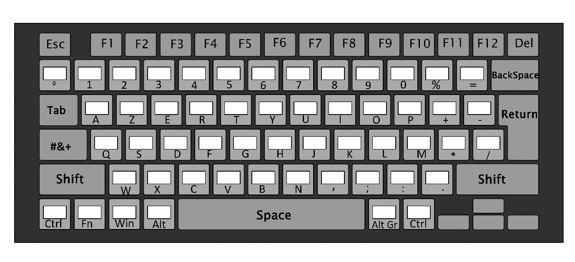**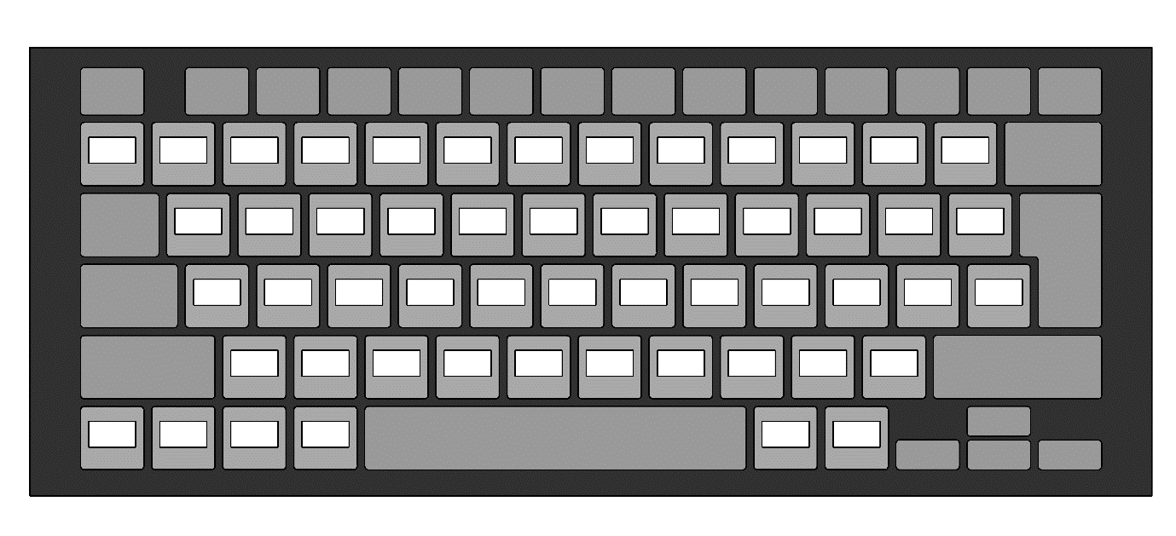Keyboard Top View**

**Y**

**X**

**Customized Keyboard Dimensions**

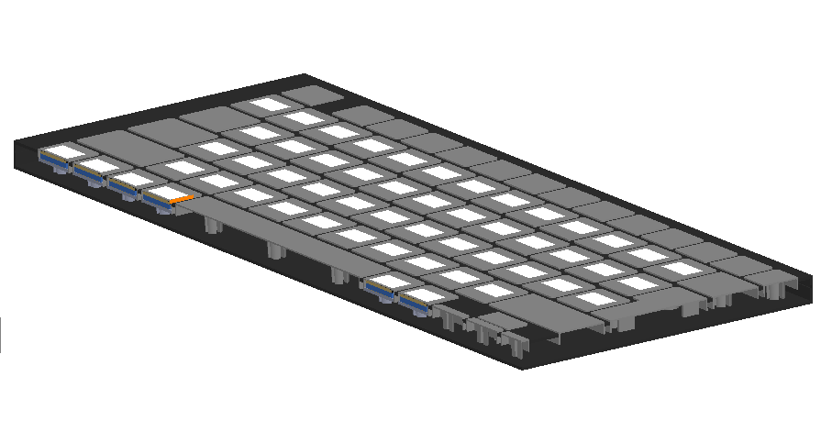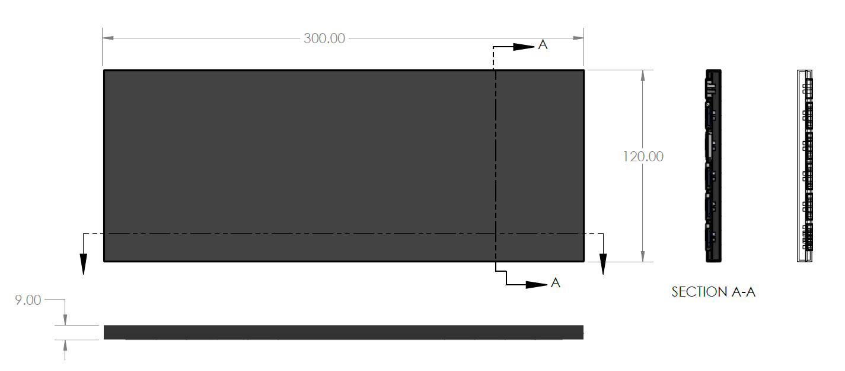

**X**

**Y**

**Customized Keyboard 3D Section View**

**Z**

**X**

**Y**

**Customized Keyboard 3D Views**

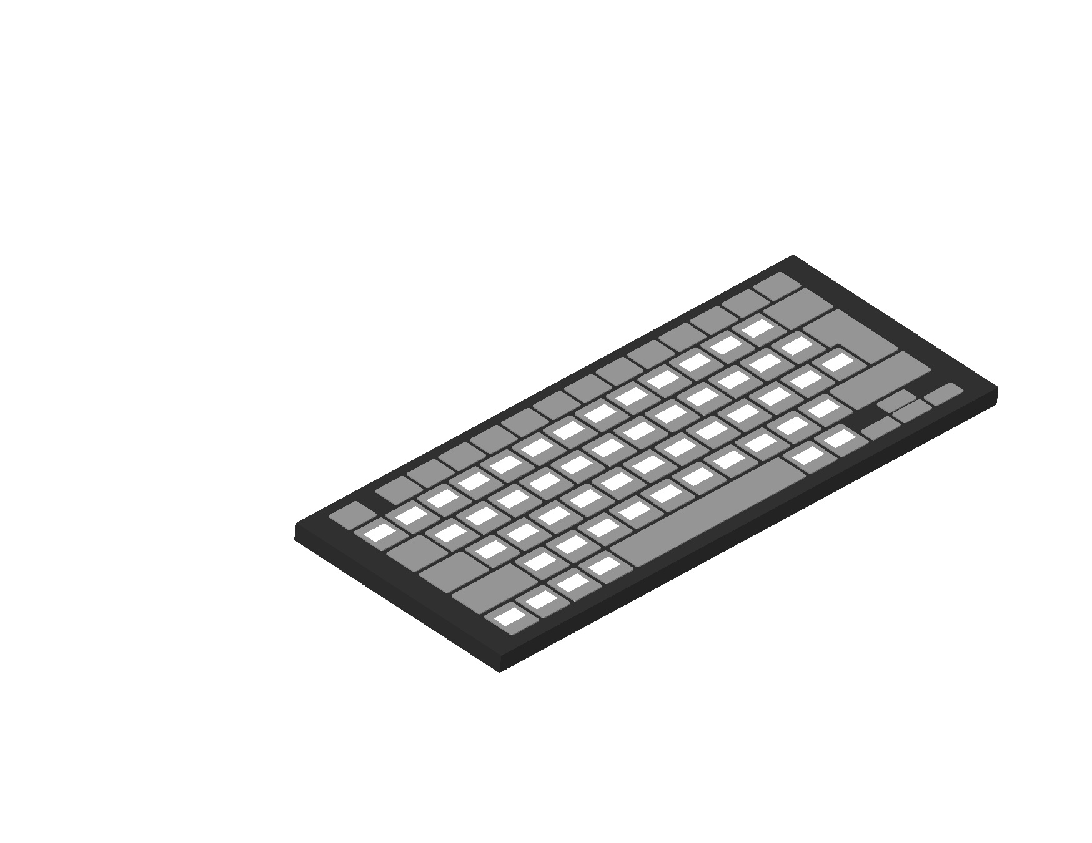

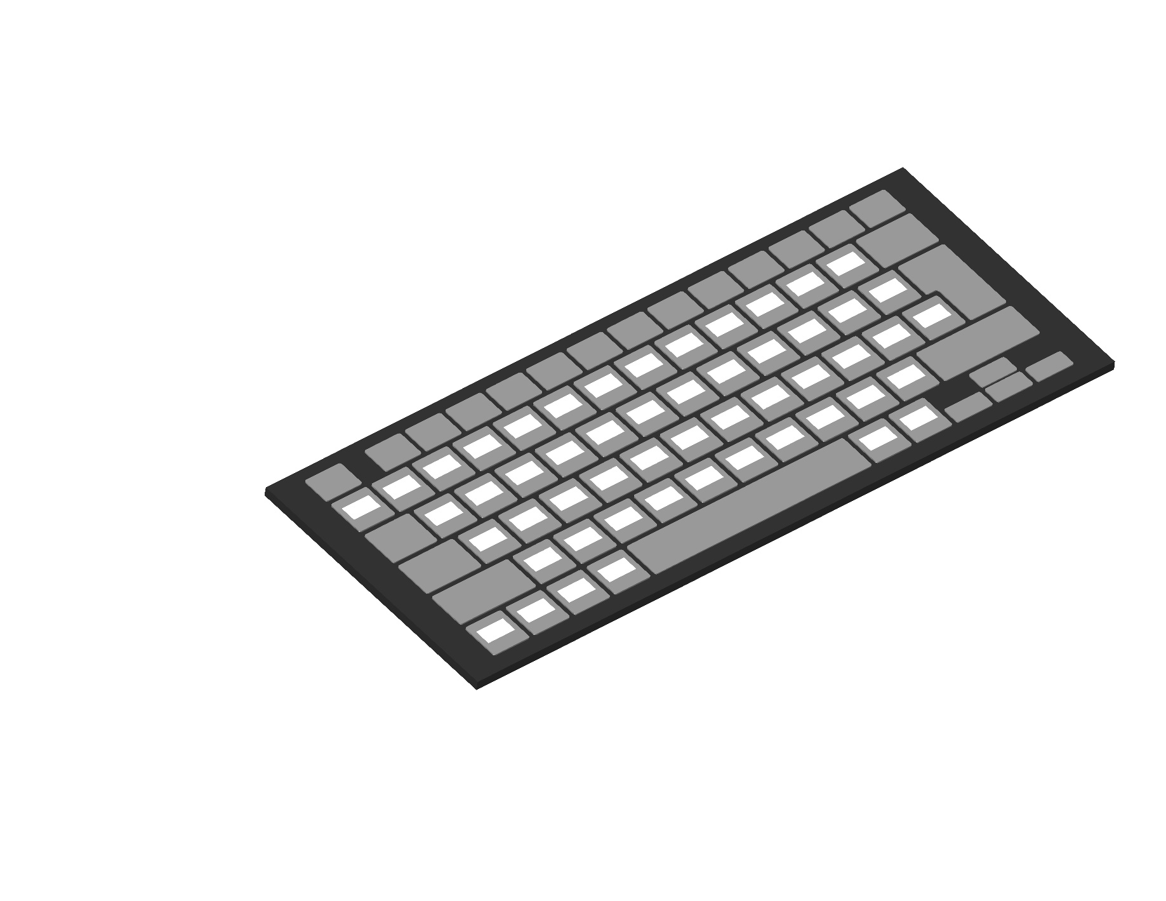

**Z**

**Y**

**X**

**Customized Keyboard OLED Placement Internal Layout.**

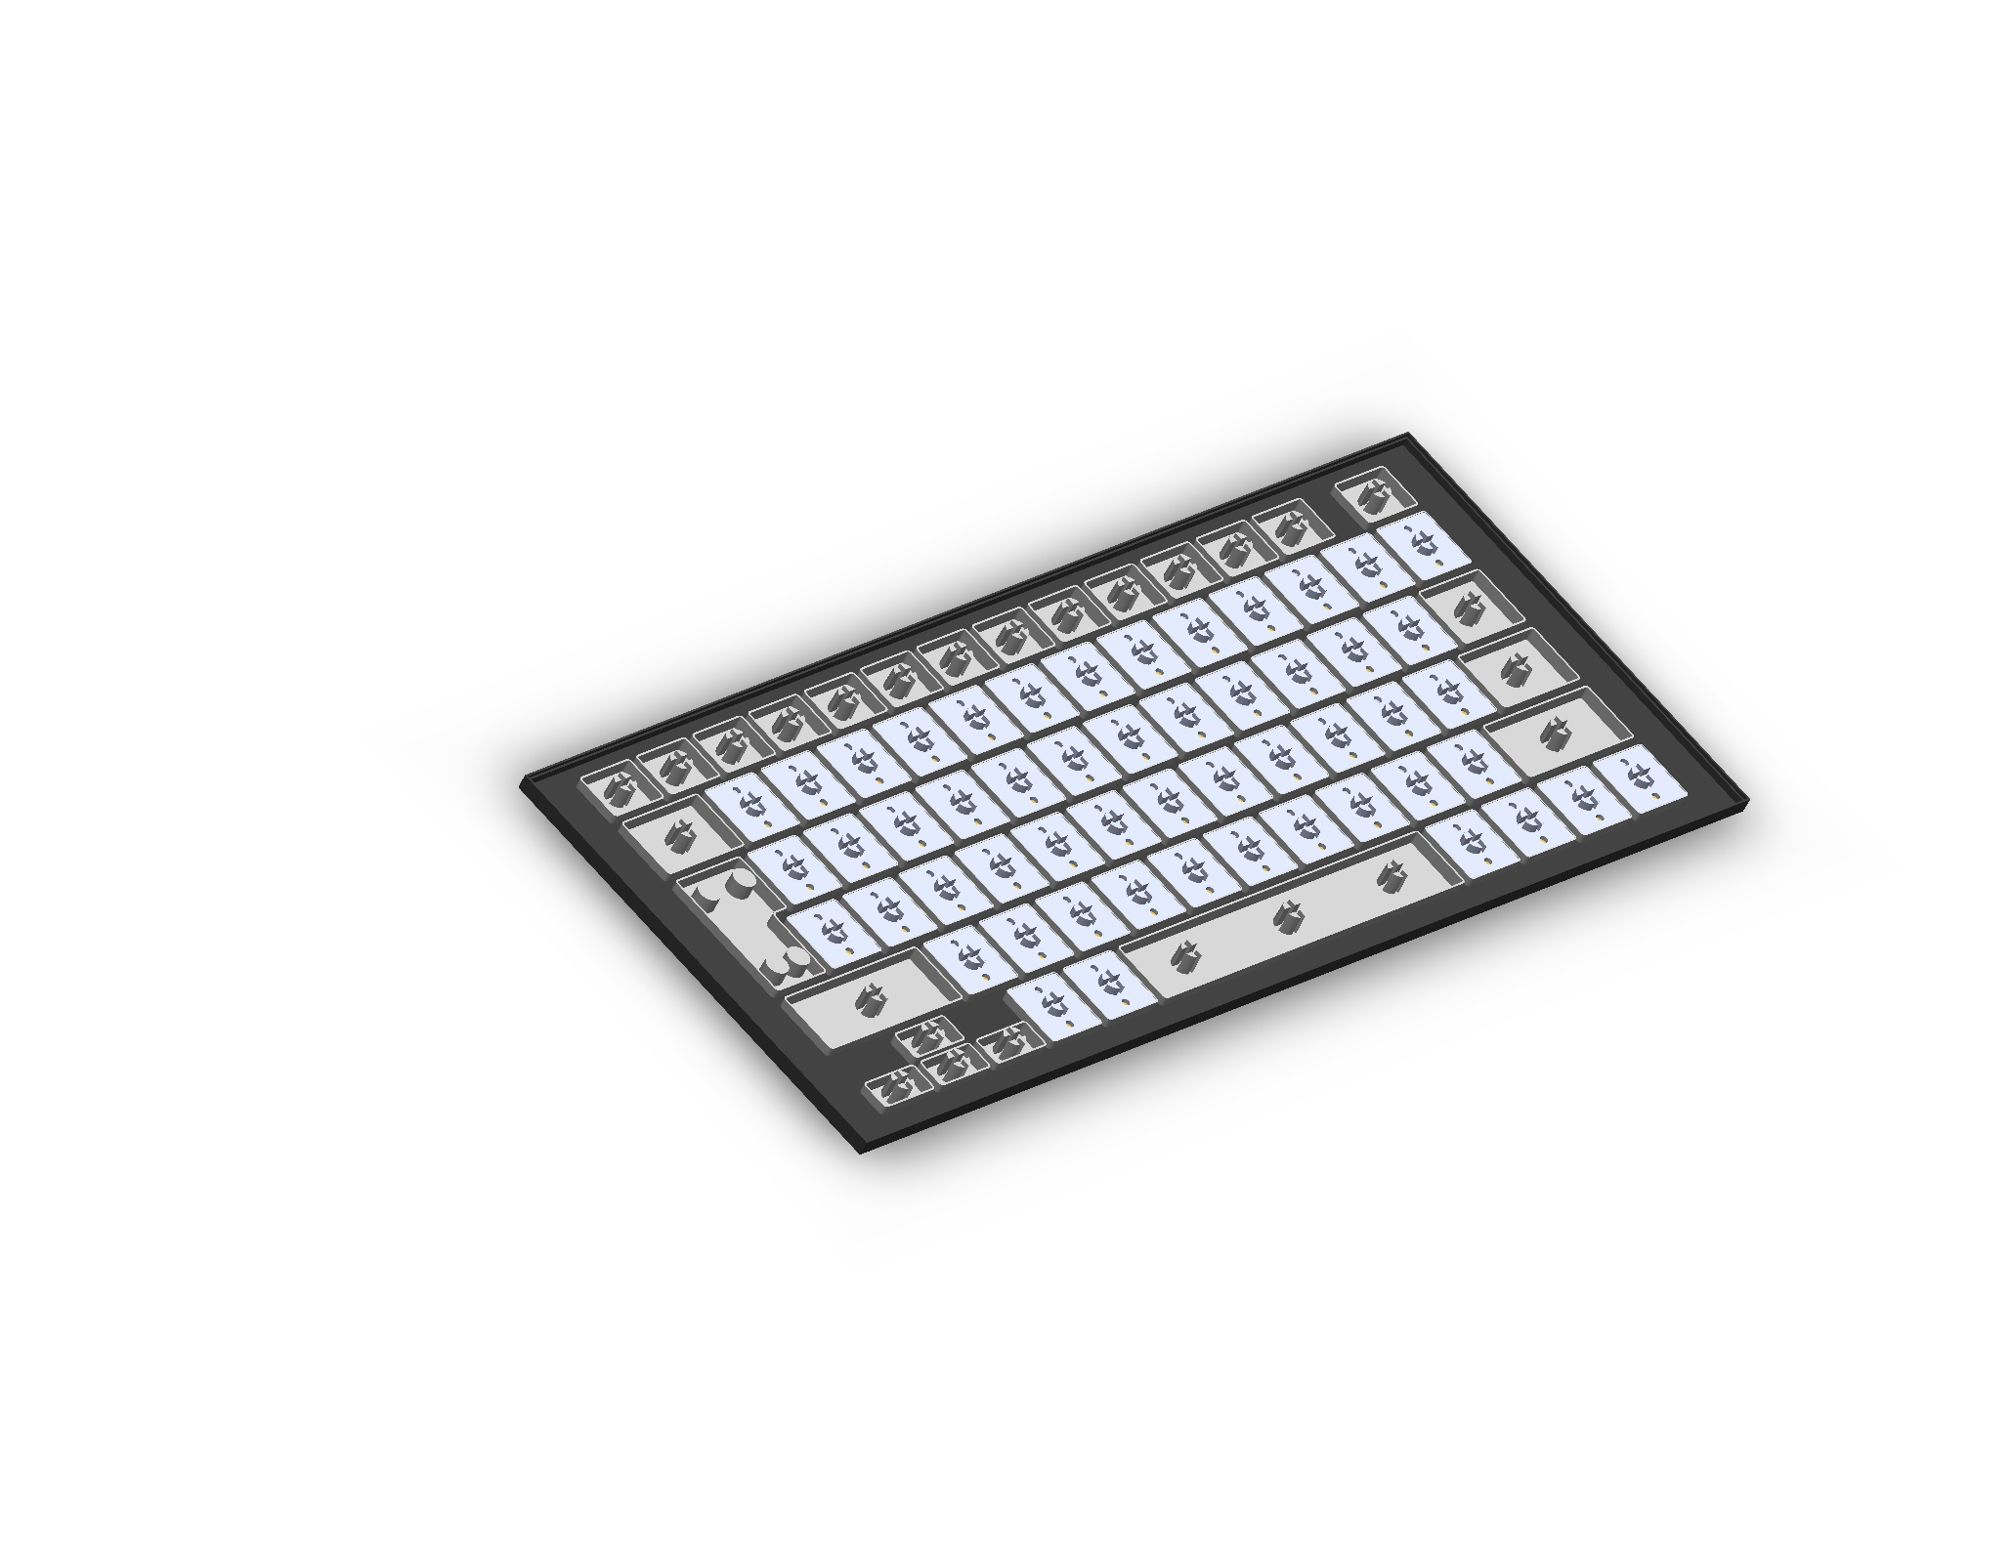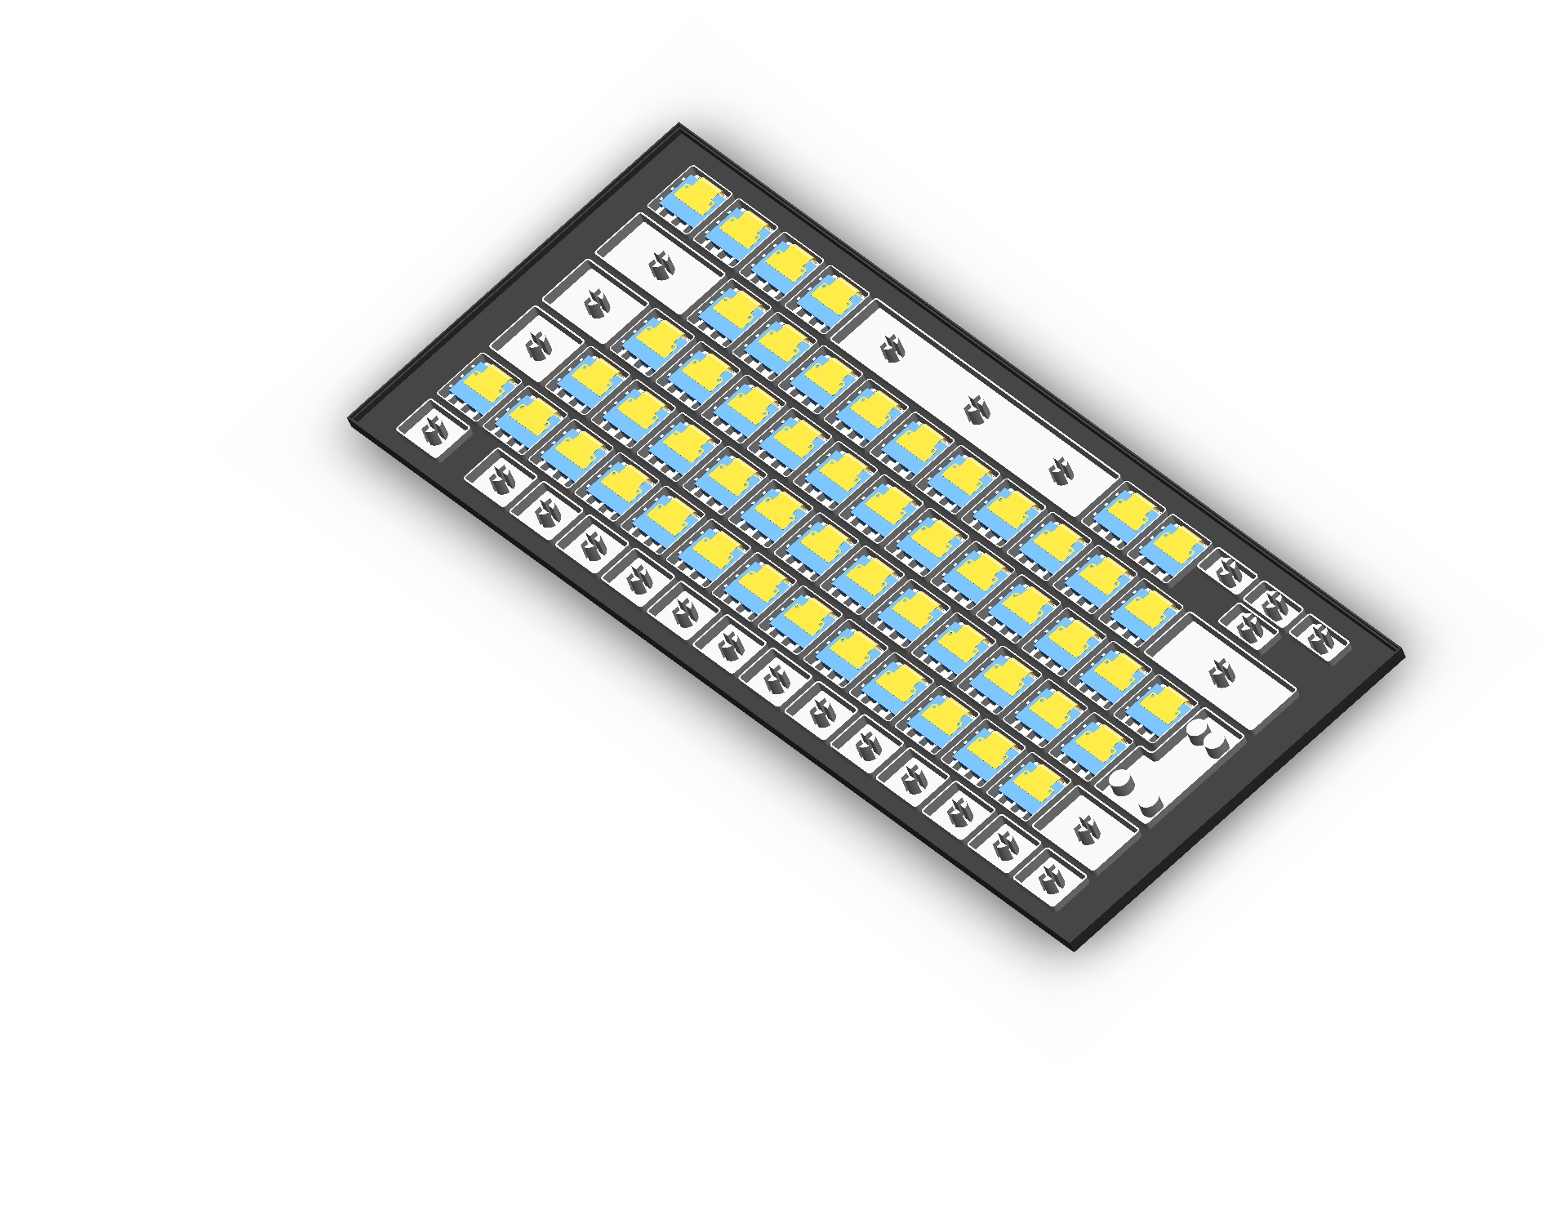

**0.49 Inches OLED**

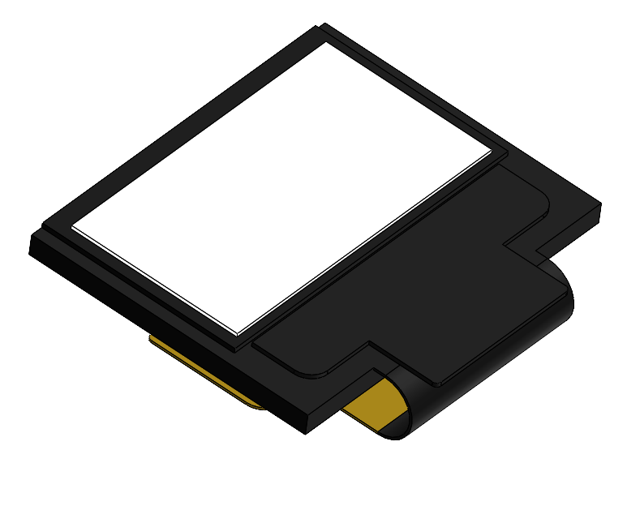

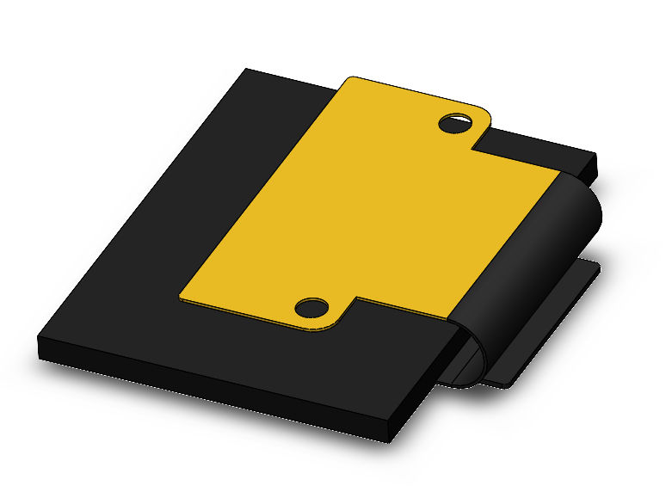

**17x17 mm Key with OLED**

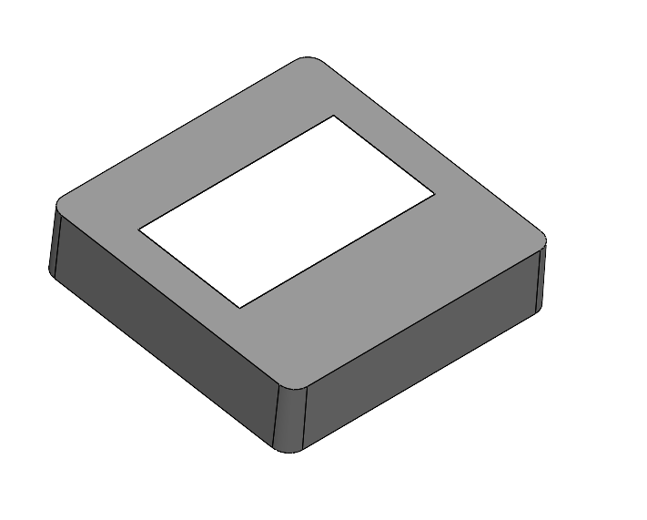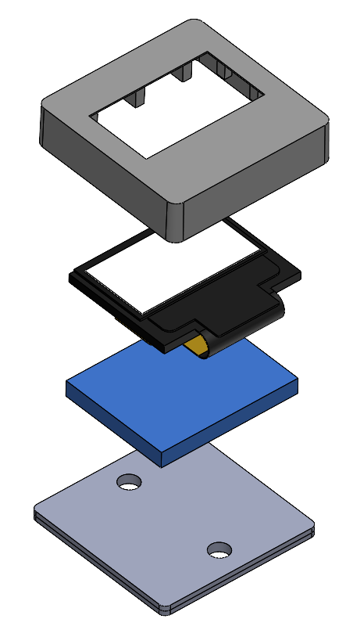

**Seal Part for Key**

**PCB**

**0.49 Inch OLED**

**Keycap for OLED**

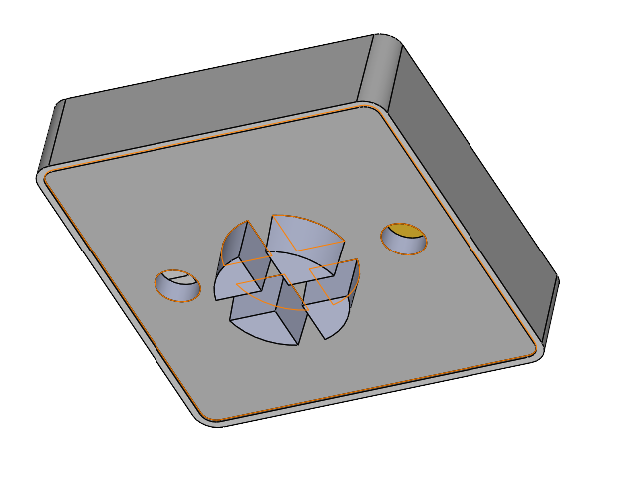

**Current Progress of the Design.**

* 0.49 Inch OLED has been placed inside the Keycap
* Envelope of the design has been completed.
* Structure of the design is 80% completed and will be finalized in parallel.
* Rendering task will be completed after all the initial work (Structure, Mass properties Analysis)
* Custom Keyboard Material. (ABS Plastic and Polyester)

Study and Analysis is going on with the material properties and have not completed yet.

* Mass Properties Analysis

MPA is going on with all the individual parts but exact values will be calculated after material selection.

It has also included the structure analysis of the complete design.

* Custom Keyboard Keys Mechanism.

Work is in progress with the keypad mechanism on Membrane method to click the keys without noisily.

Image is attached for the reference.

